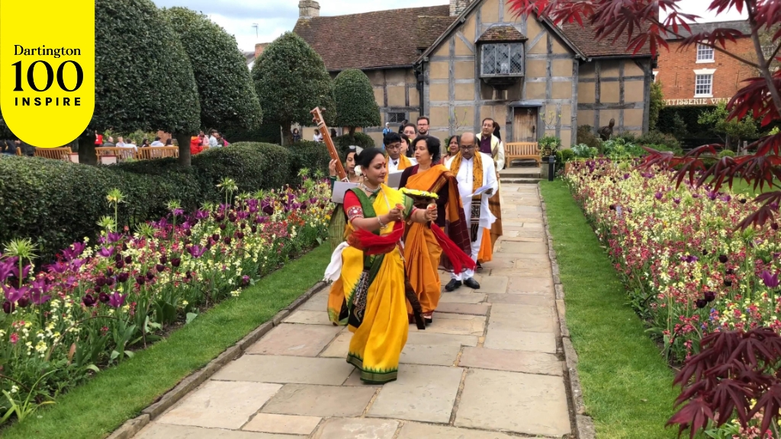
Dartington 100: Prantik to celebrate The Rabindranath Tagore Connection on his birth anniversary
On 5 May 2025, acclaimed Bengali cultural group Prantik and the Dartington Trust are inviting audiences to a special performance - Dartington 100: The Rabindranath Tagore Connection.

In this extraordinary cultural celebration, which also marks Nobel laureate Rabindranath Tagore’s 164th birth anniversary, singers, musicians and dancers from Prantik will bring to life the enduring vision of Nobel laureate Rabindranath Tagore in the magnificent Great Hall of the Dartington Estate. It will reveal the inspiration for the “Dartington experiment” through a carefully curated selection of his timeless songs and profound poetry about the universal themes of humanity, love and nature. It will include new, rhyming English translations by Prasenjit Saha that make Tagore’s genius accessible to contemporary audiences.



As Leonard Elmhirst himself acknowledged, without Tagore’s influence Dartington would never have existed. Through this unique performance, Prantik invites you to discover or rediscover the transformative power of Tagore’s art while celebrating the cross-cultural exchange and innovative thinking that defined his school in Santiniketan, the Institute of Rural Reconstruction in Sriniketan and Dartington.

“This performance by Prantik, which includes performers who grew up in Santiniketan, offers a creative opportunity to explore the connection between Rabindranath Tagore and Dartington founders Dorothy & Leonard Elmhirst”, said Dartington Head of Arts and Cultural Events, Urszula Kossakowska.

“We are honoured and thrilled to be back in Dartington to share the story of Tagore and the Elmhirsts through songs, music and dance in the special setting of the Great Hall”, added Prantik Co-Founder Obhi Chatterjee.

ENDS

Media enquiries: For more information, please contact Prantik on 020 8661 0177 or prantik@innereye.eu .

About Rabindranath Tagore

Rabindranath Tagore was a multifaceted genius who was born on 7 May 1861. He was celebrated, initially in his native Bengal, as a poet, playwright, songwriter, author, philosopher, humanist and social reformer. Later in life, he also created a dance style known as Rabindranritya and established an international reputation as a painter. He transformed Bengali literature and music, introducing modern styles and forms that blended traditional and contemporary elements.

In 1913, he won the Nobel Prize for Literature, making him the first non-European to win a Nobel Prize.

He was a visionary educator who founded a school and university in Santiniketan, promoting a holistic approach to education. His advocacy of social reform and his critique of colonialism and nationalism made him a significant figure in India’s intellectual and cultural renaissance.

In 1921, he invited Leonard Elmhirst to help him establish the Institution of Rural Reconstruction in Sriniketan. Their pioneering approach to rural development became a model for rural communities across India and provided the inspiration for the close connection between Dartington Arts School and its surrounding communities.

Tagore’s compositions include the national anthems of India and Bangladesh. His life and work continue to inspire people worldwide with themes of universal humanity and cultural harmony.

About Prantik

The Bengali cultural association Prantik was originally founded in 1976 by Jayanta, Padma and Obhi Chatterjee. Over the years, it has organised many innovative Bengali cultural events, mainly in the UK but also internationally. Between 1981 and 2009, it organised regular music classes, given by Jayanta Chatterjee, as well as Bengali classes.

Since 1996, Prantik has been celebrating the birth anniversary of Tagore every year in the garden of Shakespeare’s Birthplace in Stratford-upon-Avon. This year’s celebrations will take place on 4 May 2025, the day before their performance in Dartington.

Now led by Tagore specialists Obhi and Dr Kaberi Chatterjee, the Prantik team comprises singers, musicians and dancers who look forward to suitable opportunities to share their love of Bengali culture.

About Dartington

The Dartington Estate is set on a beautiful 800-acre estate in the South Devon countryside. It is centred on its medieval Great Hall, Courtyard and Grade II* Listed Gardens.

The “Dartington Experiment” began in 1925, when Dorothy and Leonard Elmhirst bought a crumbling estate and began to explore how a place could change the world – attracting some of the greatest artists, educators and political philosophers of the 20th century in the process. Important British institutions – including the NHS and the Arts Council – emerged, and ground-breaking experiments in land use, farming and education took place.

The Elmhirsts understood that the world and its people are complex. There are many sides to every story and to every human being. We need environments that encourage our whole being to flourish, in connection with nature and each other.

