Shakespeare’s Birthplace Marks 30 Years of Celebrating the Links Between Two Global Literary Icons with Free Performances
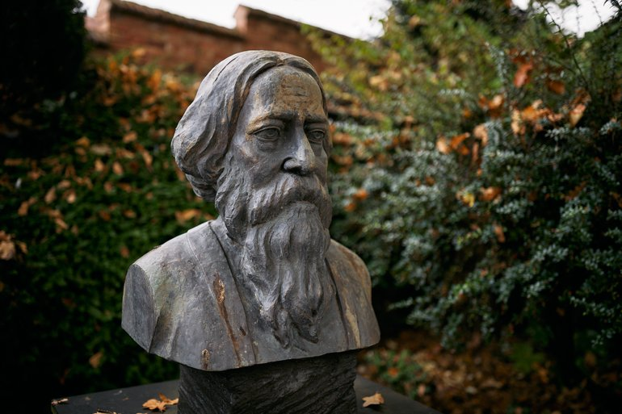
The Shakespeare Birthplace Trust (SBT) is inviting audiences to the hometown of William Shakespeare to celebrate the 164th birthday of the Indian Nobel laureate, Rabindranath Tagore and to mark the 30th anniversary of its annual Tagore commemorations at Shakespeare’s Birthplace. Expect an array of captivating performances that bring Tagore’s artistic legacy and his connections to Shakespeare to life through music and dance.
Rabindranath Tagore was born in 1861 and is perhaps best known for being the first non-European writer to be awarded the Nobel Prize in Literature. On Sunday 4 May, visitors to Stratford-upon-Avon are invited to enjoy a day of performances to remember Tagore, who was so inspired by Shakespeare that he wrote a poem in his honour.
Organisers are bringing celebrations to Henley Street and the garden of Shakespeare’s Birthplace with performances by two organisations from the South Asian community, Prantik and DESIblitz, along with an interactive dance workshop, and hands-on mural painting. This will mark Tagore's 164th birthday, which has been celebrated since a sculpture of the poet was unveiled in the Birthplace garden 30 years ago.
‘’It is important for us to celebrate Shakespeare’s legacy by commemorating other influential writers who have close links with the Stratford-born playwright and who themselves have been influenced by the works of William Shakespeare.
‘’Thank you again to Prantik and DESIblitz for joining us in filling Henley Street and the Birthplace garden with vibrant celebrations as we celebrate our shared culture.’’
Commented Rachael North, CEO at the Shakespeare Birthplace Trust.
Celebrating Tagore at Shakespeare’s Birthplace
Visitors are invited to an intimate ceremony as Shakespeare’s Birthplace plays host to its annual celebration, where audiences will gather to celebrate.
The special celebration will begin with a procession from Bengali cultural group Prantik starting from the iconic Shakespeare statue on Henley Street. The performance will end in front of the bust of Tagore located in the Birthplace garden, forming a symbolic journey between these literary giants.
‘’Together with the other members of the Prantik team, we are proud and honoured to continue the tradition of celebrating Tagore’s birthday in the garden of Shakespeare’s Birthplace, which was started in 1996 by my parents, Jayanta and Padma Chatterjee. The extensive range of Tagore’s works has allowed us to select a topical theme to introduce audiences to different aspects of his philosophy and creative genius. It is also an opportunity for the wider Bengali and Indian community to discover Shakespeare’s Birthplace.
‘’To complement the Shakespeare Birthplace Trust’s theme this year, we will be introducing the main female characters in Tagore’s works, each of whom challenged societal norms through their pursuit of love, identity and autonomy, similar to Shakespeare’s iconic female characters. Our performance will bring their stories to life, resonating with Shakespearean themes of transformation and justice’’
Commented Obhi Chatterjee, Consultative Council member at the Shakespeare Birthplace Trust.
Prantik’s performance will culminate with a special show and short ceremony with a selection of Tagore songs, inspired by his female characters in the intimate surroundings of the Birthplace garden.
Bringing the Celebrations to Henley Street With Desiblitz
British Asian Lifestyle brand DESIblitz are once again joining forces with the Trust to bring its celebrations to Henley Street, where all will be treated to special performances with a group of classical Indian musicians singing and playing Tagore’s most famous works.
The team’s special Truck Art Bus, a striking mobile stage hand-painted by Haider Ali, the world’s leading Pakistani truck artist, is returning to Shakespeare’s Birthplace for this occasion. The bus is set to transform into a vibrant performance space, bringing Tagore’s poetic and musical legacy to life through live music and interactive dance.
Those visiting Shakespeare’s Birthplace or simply passing by can expect a vibrant street scene as there will be cushions and deckchairs out on Henley Street, surrounding the colourful bus. All are welcome to sit back, relax and soak in the exciting atmosphere as they watch the captivating performances.
Rowshanara Moni, the acclaimed Bollywood and Bengali singer and actress, will perform beautiful musical pieces inspired by Tagore’s work, transporting audiences with her soulful renditions. Senjuti Das, a highly skilled Odissi dancer, will engage audiences with captivating dance performances, inviting everyone to learn, participate and experience this classical Indian dance form with an interactive dance workshop.
"We are honoured to continue our collaboration with the Shakespeare Birthplace Trust in celebrating the birthday of Rabindranath Tagore, whose literary genius and visionary spirit transcend borders and generations. At DESIblitz, we recognise the power of storytelling to unite and inspire, and Tagore’s poetry stands as a profound testament to this. Like Shakespeare’s, his words echo the universal themes of love, identity, and freedom.
‘’This year, we aim to bring his poetry to life once again, not only through art and music but also with the addition of classical dance, creating a truly immersive experience that honours his enduring legacy and brings his works in a new and exciting way.’’
‘’By celebrating his life and legacy, we not only pay tribute to an extraordinary cultural icon but also provide a deeper understanding of the diverse voices that shape our global narrative. We are proud to join the community in embracing his timeless contributions through art, music, dance and shared experience on Henley Street.’’
Added Indi Deol, director at DESIblitz.
Celebrations do not end there. Throughout the day guests are invited to have a go at creating a mural with local artist Haseebah Ali using printing techniques and traditional South Asian designs. Through this interactive activity, guests can get creative exploring Shakespeare’s legacy, Tagore’s works and what it means to them today.
For more information about the free celebrations on Henley Street, visit https://www.shakespeare.org.uk/visit/whats-on/tagore-birthday-shakespeares-birthplace/ .
ENDS

Press release issued by the Shakespeare Birthplace Trust. For more information, please contact Press Info 01789 204016 or email pressinfo@shakespeare.org.uk
Exploring Tagore’s Lasting Legacy
Born in 1861, Rabindranath Tagore is perhaps best known for being the first non-European writer to be awarded the Nobel Prize for Literature in 1913 for his poetry. Two of his songs are also the national anthems for India and Bangladesh.
Shakespeare was a great influence on Tagore. The poem, ‘In Honour of William Shakespeare’ honours the playwright as both an English and world poet that shaped literature and culture as we know it.
The poem is now engraved and on permanent display with the bust of Tagore situated in the Birthplace Garden, which was unveiled 30 years ago, and where celebrations have taken place since. Like Shakespeare, Tagore’s works have a broad, timeless appeal that diverse communities worldwide continue to celebrate through many artforms.
Notes to Editors

About the Shakespeare Birthplace Trust

The Shakespeare Birthplace Trust is the charity that cares for the world’s greatest Shakespeare heritage in his home town of Stratford-upon-Avon. It is the global centre for learning about and experiencing the works, life and times of the world’s best-known writer. Through the five historic Shakespeare family homes (Shakespeare’s Birthplace, Shakespeare’s New Place, Anne Hathaway’s Cottage, Mary Arden’s Farm, Hall’s Croft), internationally designated museum, library and archive collections, award-winning learning programmes and digital channels, it provides imaginative, immersive and interactive opportunities for people of all ages and backgrounds to get up-close-and-personal with Shakespeare.

The Shakespeare Birthplace Trust is a charity which generates its income through the support of visitors, donors, volunteers and Friends. In April 2018 it was granted National Portfolio funding from Arts Council England for the first time, enabling new creative and outreach programmes with a particular focus on communities which are currently less engaged in arts, culture and heritage. For more information, visit www.shakespeare.org.uk or follow us on social media @ShakespeareBT.

About Arts Council England
Arts Council England is the national development agency for creativity and culture. Arts Council England has set out its strategic vision in Let’s Create that by 2030 it wants England to be a country in which the creativity of each of us is valued and given the chance to flourish and where every one of us has access to a remarkable range of high-quality cultural experiences. Arts Council England invest public money from Government and The National Lottery to help support the sector and to deliver this vision. www.artscouncil.org.uk

